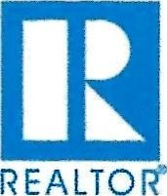
WESTERN NEBRASKA BOARD OF REALTORS®
APPLICATION FOR REALTOR® MEMBERSHIP

1 hereby apply for REALTOR@ Membership in the WESTERN NEBRASKA BOARD OF
REALTORS® and will submit full payment upon receipt of the invoice, which will include a onetime application fee of $250 for the 2026 year payable to the Western Nebraska Board of REALTORS ®. I understand that my dues will be returned to me in the event of non-election and that the application fee is non-refundable. I will attend orientation within 60 days of the Association’s confirmation of membership. Failure to meet this requirement may result in having my membership terminated. In the event of my election, I agree to abide by the Code of Ethics of the NATIONAL ASSOCIATION OF REALTORS®, which includes the duty to arbitrate (or to mediate if required by the association) and the Constitution, Bylaws and Rules and Regulations of the above named Association, the State Association and the National Association, and if required, I further agree to satisfactorily complete a reasonable and non-discriminatory written examination on such Code, Constitutions, Bylaws and Rules and Regulations. I understand membership brings certain privileges and obligations that require compliance. Membership is final only upon approval by the Board of Directors and may be revoked should completion of requirements, such as orientation, not be completed within the timeframe established in the association's bylaws. I understand that I will be required to complete periodic Code of Ethics training as specified in the association's bylaws as a continued condition of membership.
NOTE: Applicant acknowledges that if accepted as a member and he/she subsequently resigns from the
Association or otherwise causes membership to terminate with an ethics complaint pending, the Board of Directors may condition renewal of membership upon applicant 's certification that he/she will submit to the pending ethics proceeding and will abide by the decision of the hearing panel. If applicant resigns or otherwise causes membership to terminate, the duty to submit to arbitration continues in effect even after membership lapses or is terminated, provided the dispute arose while applicant was a REALTOR®.

PERSONAL INFOR |  |  |  |  | MATION:
First Name |  |  |  |  |  |  |  |  |  |  |  |  | Middle Name
Last Name |  |  |  |  |  |  |  |  |  |  |  |  | Suffix: Jr, Sr, Ill, Etc.
Nickname (DBA):
Home Address:
City: |  |  |  |  |  |  |  | State: |  |  |  |  |  |  |  |  |  |  |  |  | Zip:
Home Phone: |  |  |  |  |  |  |  |  |  |  | Cell Phone:
Personal Fax:
E-mail Address: |  |  |  |  |  |  |  |  |  |  |  |  |  |  | Secondary E-mail:
License #  Real Estate License |  |  |  |  |  |  |  |  |  | DATE of License:
Licensed/Certified |  |  |  |  | Appraiser: Yes __ No__ |  |  |  |  |  | Appraisal License #
COMPANY INFORMATION:

Office Name:
Office Address:
Office Phone: |  |  |  |  |  |  |  |  |  |  |  |  |  |  |  | Fax:
Company Type: Sole Proprietor Partnership Corporation LLC (Limited Liability Co)
Other, specify
Your position: Principal Partner Corporate Officer [Majority Shareholder
C] Branch Office Manager Non-principal Licensee Other
Names of other Partners/Officers/ of your firm:
PREFERRED MAILING/CONTACT INFORMATION:
Initial Password for Association Site (if applicable):
Preferred Phone: Home Office _____Cell______
Preferred E-mail: Primary E-mail Secondary E-mail
Preferred Mailing: Home Office Office Mail Alternate Member Mail Alternate
Mail Publications to: Home Office Office Mail Alternate Member Mail Alternate
Office Mailing Alternate:
Address:
City: | State: |  |  |  |  |  |  |  |  |  |  |  |  |  |  |  |  |  |  |  |  | Zip:
Member Mailing Alternate Address:
City: |  |  |  |  |  |  |  |  | State: |  |  |  |  |  |  |  |  |  |  |  |  | Zip:

APPLICANT INFORMATION:
Are you presently a member of any other Association of REALTORS®? Yes____ No____ If yes, name of Association Type of membership held:____________________________________________________

Have you previously held membership in any other Association of REALTORS®? Yes____ No______
If yes, name of Association Type of membership held: ________________________________________________

Have you been found in violation of the Code of Ethics or other membership duties in any Association of
REALTORS@ in the past three (3) years or are there any such complaints pending? Yes _______ No ______
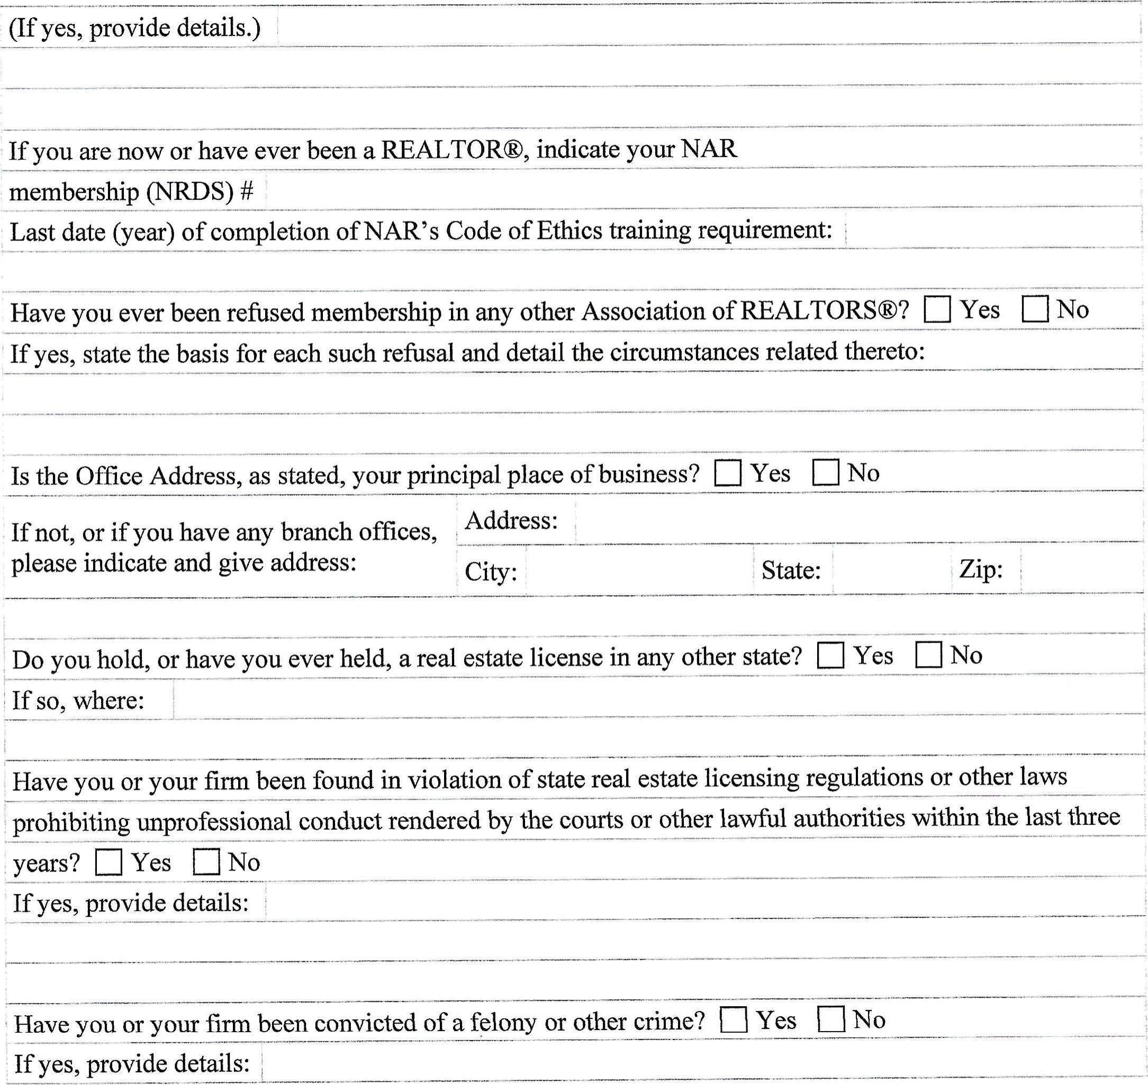
I hereby certify that the foregoing information furnished by me is true and correct, and I agree that failure to provide complete and accurate information as requested, or any misstatement of fact, shall be grounds for revocation of my membership if granted. I further agree that, if accepted for membership in the Board, I shall pay the fees and dues as from time to time established.

NOTE: Payments to the WESTERN NEBRASKA REALTORS® are not deductible as charitable contributions. Such payments may, however, be deductible as an ordinary and necessary business expense. No refunds.
By signing below I consent that the REALTOR@ Associations (local, state, national) and their subsidiaries, if any (e.g., MLS, Foundation) may contact me at the specified address, telephone numbers, fax numbers, email address or other means of communication available. This consent applies to changes in contact information that may be provided by me to the Association(s) in the future. This consent recognizes that certain state and federal laws may place limits on communications that I am waiving to receive all communications as part of my membership.

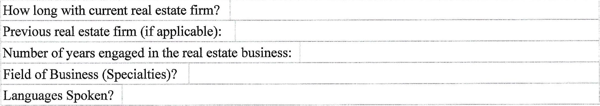
Dated:
Signature:

INFORMATION TO BE SUPPLIED BY LOCAL ASSOCIATION
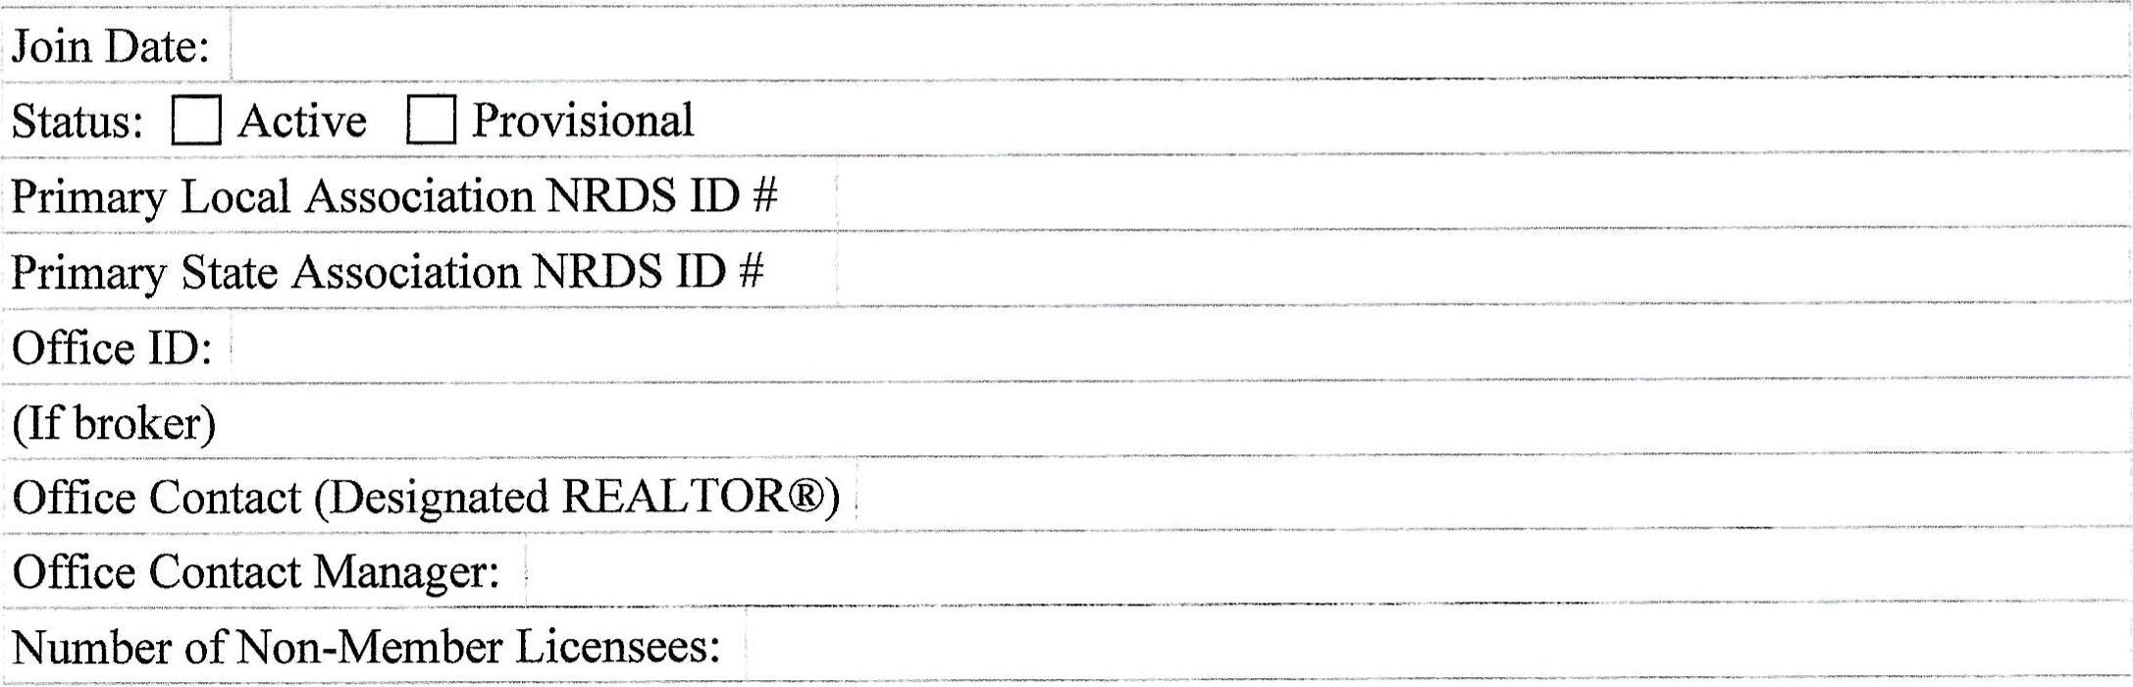

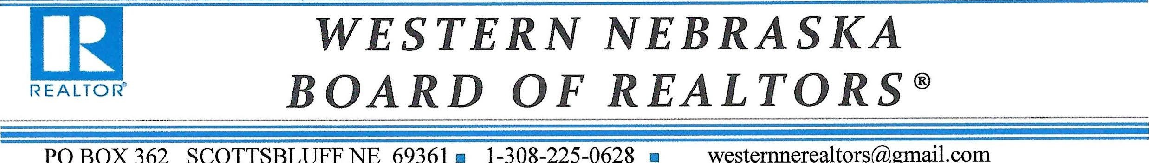

AGREEMENT AND NOTICE OF REQUIREMENTS FOR
WESTERN NEBRASKA BOARD OF REALTORS® MEMBERSHIP
understand that my membership is subject to the following conditions:
Approval by the Western NE BOR Board of Directors of my Application, completion of all Western NE BOR Training videos, new member code of ethic, new member orientation, and full payment of all applicable fees associated with membership.
By signing below I consent that the REALTOR® Associations (Local. state, national) and their subsidiaries, if any (e.g, MLS, Foundation) may contact me at the specified address, telephone numbers, fax numbers, email address or other means of communication available. This consent applies to changes in contact information that may be provided by me to the Association(s) in the future. This consent recognizes that certain state and federal laws may place limits on communications that I am waiving to receive all communications as part of my membership,
Signed
Date

FOR MLS PARTICIPANTS
ACCESS TO THE WNBOR MLS:
Log on to site: https://sbcb.paragonrels.com
Username/Login Name
PASSWORD: agent will create their own password via paragon email services after account is created.
(Agent to provide information- no spaces - up to 10 characters ALL LOWERCASE)

MLS Participation Agreement
For MLS access by REALTOR@ (principals) or a firm comprised of REALTOR@ (principals) who are members of the Western Nebraska Board of REALTORS @. (Board/association.)

Name:_______________________________________________________________
Office Address:

BOARD ASSOCIATION NAME WHERE PRIMARY MEMBERSHIP IS HELD:
WESTERN NEBRASKA BOARD OF REALTORS®

I agree as a condition of participation in the MLS to abide by all relevant Bylaws, Rules and other obligations of participation including payment of fees. I further agree to be bound by the Code of Ethics on the same terms and conditions as board/association
members including the obligation to submit to ethics hearings and the duty to arbitrate contractual disputes with other REALTORS@ in accordance with the established procedures of the board/association. I understand that a violation of the Code of Ethics may result in termination of my MLS privileges and that I may be assessed an administrative processing fee which may be in addition to any discipline, including fines, that may be imposed
Signature:______________________________________________________

Date
NOTE: If the Board intends to discipline MLS Users and/or Subscribers directly, each User and/or Subscriber must sign this form in the space provided. Please refer to the section of the Handbook on Multiple Listing Policy_ entitled Applicability of Rules to Users and/or Subscribers for information on establishing authority to impose discipline on non-principal "users" or "subscribers" affiliated with MLS "Members" or "Participants."

WESTERN NEBRASKA BOARD OF REALTORS® REGIONAL MLS
SENTRILOCK SMART CARD AUTHORIZED USER AGREEMENT
IT IS HEREBY AGREED BETWEEN THE WESTERN NEBRASKA BOARD OF REALTORS® REGIONAL MLS
AND MLS PARTICIPANT (known as 'Authorized User')

(Name of MLS Participating Broker and Company)
AND MLS PARTICIPANT'S LICENSEE ('Authorized User' or 'Agent')

(Name of Agent)
- SMART CARD RECEIPT: Participant and Agent acknowledge receipt of a SentriLock Smart Card from the MLS.
- TITLE TO SMART CARD: Participant and Agent acknowledge that the Smart Card shall be the sole property of SentriLock and shall be returned as required by Sentrilock or the MLS.
- CARD EXCHANGE BY SENTRILOCK OR MLS: SentriLock may at its discretion require the MLS to replace the Smart Cards used by the MLS and it's Authorized Users with replacement Smart Cards compatible with the system. SentriLock shall make the exchange of Smart Cards at no cost to the MLS unless the exchange is necessary due to Customer negligence.
- CURRENT UPDATE: Agent acknowledges that the Smart Card has an update and that this code expires at regular intervals determined by the MLS, prohibiting further use of the Smart Card until a new update is obtained from the MLS by placing the Smart Card in an MLS Card Reader or by another authorized method.
- TERM OF AGREEMENT: The term of this Agreement begins on the date of the execution of this Agreement and ends on the date the Authorized User terminates Membership with the MLS and returns the Smart Card to the MLS. User is assessed a $25 administrative set up charge payable upon receipt of application.
- RETURN OF SMART CARD: Participant and Agent agree to return the Smart Card within the earlier of (1) 48 hours of receipt of a request to do so by the MLS or SentriLock or (2) within five working days after occurrence of any of the following events: a. Termination of a Participant as a Participant in the MLS.
  - Termination of Agent's association with the said Participant for any reason.
  - Failure of the Participant/Agent to perform in accordance with any and/or all tenns and conditions herein set forth, including, but not limited to, the provisions for security in paragraph 7 below.
  - In the event of the death of the Participant/Agent, heirs or personal representatives will surrender the Smart Card to MLS.
- SECURITY OF SMART CARDS / APP: Participant and Agent acknowledge that it is necessary to maintain security of the Smart Card to prevent its use by unauthorized persons. Consequently, Authorized User agrees:
  - To keep the Smart Card in Agent's possession or in a safe place at all times.
  - To not allow his/her personal identification number (PIN) to be attached to the Smart Card or disclose to any third party his/her identification number (PIN).
  - DO NOT LOAN THE SMART CARD TO ANY PERSON FOR ANY PURPOSE WHATSOEVER OR TO PERMIT THE SMART CARD TO BE USED FOR ANY PURPOSE BY ANY PERSON.
  - personal To not duplicate the Smart Card or allow any person to do so.
  - To not assign, transfer or pledge the rights of the Smart Card.
  - To notify the MLS within three days of the loss of theft of a Smart Card. The Participant/Agent shall sign and deliver a statement to the MLS with respect to the circumstances surrounding the loss or theft. MLS shall charge for the replacement of Smart Cards either lost or damaged.
  - To follow all additional security procedures as specified by the MLS.
- REPLACEMENT SMART CARDS: N/A -App based service only.
- DISCIPLINARY ACTION: Participant and Agent agree to be subject to the disciplinary rules and procedures of the (MLS)
Professional Standards Committee for violation of any provision of this Agreement. Discipline may include forfeiture of the Smart Card and the Participant or Agent's right to be issued a Smart Card.
- INDEMNIFICATION: Participant and Agent agree to indemnify and hold the MLS and all of its respective officers, directors and employees harmless from any and all loss, cost, expense, claims or demands whatsoever by or against the NILS resulting from loss, use or misuse of the SentriLock System, including, but not limited to, any and all liabilities, including attorney's fees, incurred by them as a result of damage or injuries to property or persons arising out of entry by any person into any premises by use of the SentriLock System.
- REIMBURSEMENT: Participant and Agent agree that, in the event that the MLS shall prevail in any legal action brought by or against the Participant/Agent to enforce the terms of this Agreement, the Participant/Agent as appropriate may be assessed a reasonable amount of attorney's fees in addition to any other relief to which the Court rules the MLS may be entitled.
- GOVERNING LAW: The validity of this Agreement and any of its terms and provisions, as well as the rights and duties of the parties hereunder, shall be governed by the laws of (STATE NAME), and venue shall be the county in which the Participant and/or Agent reside.
- PARTIAL INVALIDITY: If any provision of this contract is held by any court to be invalid, void or unenforceable, the remaining provisions shall nevertheless continue in full force.
- DISCLOSURE TO CLIENTS: The Listing Participant/Agent shall obtain specific written authorization from the seller before placing a lockbox on the owner's property and before the listing is inputted to the MLS, reflecting that a lockbox has been authorized by seller.
- PARTICIPANT'S RESPONSIBILITIES:
  - Participant warrants that Participant is both a licensed real estate broker and Participant of the (IVLS Name).
  - Participant warrants that Agent possesses a real estate license and is in fact associated with Participant in an active effort to sell real estate or is a licensed or certified real estate appraiser affiliated with the MLS Participant.
  - Participant agrees to enforce the terms of the Agreement with respect to any Agent associated with him/her and understands that he/she is not relieved of any responsibility or obligation by the mere fact of such disassociation with Agent.
  - Participant agrees to notify the MLS immediately, in writing, should the Participant or Agent terminate their relationship or should the Agent's license be transferred.
  - Participant agrees to take all responsible means to obtain Agent's Smart Card or cause Agent to return Smart Card to NILS. The Participant will continue to be charged a service fee for the disassociated subscriber until the next billing cycle after the card is returned. If an Agent does not return the Smart Card, Participant agrees to furnish the MLS with copies of written correspondence of all attempts made to obtain said Smart Card.
  - Participant agrees that he/she is jointly and severally liable, together with the Agent, for all duties, responsibilities and undertakings of the Agent under this Agreement and understands that failure to follow the provisions of the SentriLock Smart Card User Agreement may result in the loss of MLS Smart Card privileges and, further, could cause the MLS to recall all Smart Cards issued to the Participant and the Participant's Agents.
- ADDITIONAL CONDITIONS SET FORTH ON THE SECOND PAGE HEREOF ARE PART OF THIS AGREEMENT:
This written contract expresses the entire agreement between Participants, Agents and the MLS with respect to SentriLock Smart Cards. This Agreement supersedes any and all other agreements, either oral or in writing. No other agreement, statement or promise relating to the subject matter of the Agreement which is not contained herein shall be valid or binding. This Agreement is binding upon the heirs and personal representatives of the Participant or Agent.
AGENT:__________________________________________________ DATE: _________________
PARTICIPANT BROKER: _________________________________ DATE:_________________
BY WESTERN NEBRASKA REGIONAL MLS__________________________ DATE

MARKETING CONSENT FORM
NAME:
COMPANY NAME:
ADDRESS:
CITY, STATE, ZIP:
CELL NUMBER:________________________________ TELEPHONE NUMBER:_____________________

E-MAIL:

(MAY INCLUDE NUMBERS FOR BOTH HOME AND WORK CONTACT)
BY signing below, I consent that the REALTORS Associations and subsidiaries, if any, may contact me at the specified address, telephone number, fax number, email address or other means of communication available.

This consent applies to changes in contact information that may be provided by me to the Association in the future. This consent recognizes that certain state and federal laws may place limits on communication, and I am waiving to receive all communications as part of my membership.

SIGNATURE: ______________________________________________ DATE:

